**PROJECT SYNOPSIS**

OF PROJECT-1

Title:

Middiater website

**BACHELOR OF TECHNOLOGY**

COMPUTER SCIENCE AND ENGINEERING

SUBMITTED BY

NAME: **CHANDRA PRAKASH**

CLASS ROLL NO.: **324**

UNIV. ROLL NO.: **1906929**

YEAR: **3rd year**

**Malout Institute of Management and Information Technology, Malout And**

**attainU Project**

**INDEX**

|  |  |  |
| --- | --- | --- |
| Serial  No. | Description | Page  No. |
|  |  |  |
| 1) | Introduction of project | 3 |
| 2) | Feasibility Study of Project |  |
| 3) | Planning of work |  |
| 4) | Requirements |  |
| 5) | References |  |

**Introduction of Project**

* This project is basically based on full stack development and .
* In this project you can purchase all software related products.
* A website that allows people to buy and sell physical goods, services, and digital products over the internet rather than at a brick-and-mortar location. Through an e-commerce website, a business can process orders, accept payments, manage shipping and logistics, and provide customer service.
* Showcase what you’re selling in a beautiful catalogue, with a scrollable carousel. Analytics and machine learning lets your app figure out which products customers want and displays tailored recommendations in their feed.

**Feasibility Study**

* This can be easily developed because in present there is lots of java script and flutter available.
* Its run on browser only need to develop this website pc have 4 gb ram 256ssd.
* A lot of study about user interface and server shide architecture .
* Cloudinary for images upload and a lot of thing about that.

**Planning of work**

1. First Need the development Setup “visual studio code” install node js .
2. You have knowledge about express html5 CSS JS and MongoDb

Handlebars for dynamic web page.

3.then design backend for testing purpose of backend use postman

4.collect images and other thing .

5.you can use api and other thing to find product data fake api of Google.

6.json file format also knoeledgable for thai ecommerce because bethought json file you can’t use no SQL database and API.

7. Make flow chart of working website

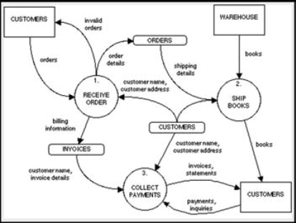

**Requirements**

* A PC
* MongoDb
* Nodejs
* Js
* Multer
* Express
* No SQL
* JSON
* HandleBars
* Bootstrap

**References**

* Using package npm
* Instruction to build from npm.dev
* W3 School
* You tube
* And also from internet search.